**Fire Fighter Finger Puppet**

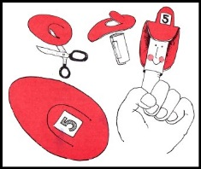

**Materials:**

**white paper, scissors, glue or tape, red** [construction paper](http://www.alphabet-soup.net/firesafety/firesafety.html) **or felt, black and red** [markers](http://www.alphabet-soup.net/firesafety/firesafety.html)

**Directions:**

1. **Cut a rectangle measuring 2 1/2" x 3 1/2" out of white paper.**
2. **To form cylinder, wind the rectangle around your finger.**
3. **Remove from finger and glue or tape the cylinder together.**
4. **Reproduce the hat pattern below.**
5. **Cut out and trace on red construction paper or felt. This will be the firefighter's hat.**
6. **Put scissors through the paper or felt; cut out the arc shape.**
7. **Glue the front of the hat and the back onto the cylinder, the arc extending out. (see illustration)**
8. **Add firefighter's features on the cylinder using a black marker and shade the cheeks with a red marker.**
9. **Write the fire squad number on a small white square and glue it to the arc.**